Scalar and Vector numbers
Measurement of different physical properties are represented by either scalar or vector quantities.
A scalar quantity is just a typical real number: e.g., temperature, pressure, energy.
A vector quantity is a set of numbers that represents a directed line segment that has a length and a direction: e.g., velocity, momentum, electric or magnetic or gravitational fields. Vectors can be added/subtracted BUT NOT multiplied/divided!!
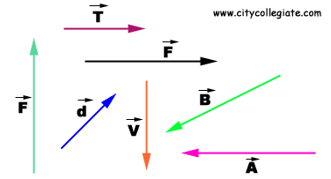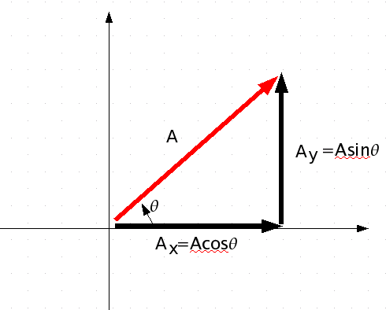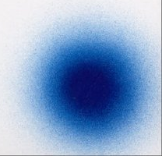
Dimensional analysis of Units
There are two kinds of numbers: pure numbers without units and measurement numbers that have units.
Examples of pure numbers come from mathematics such as π. C (m) = 2(no units)*π(no units)*R (m).
Example of measurement numbers: anything you measure! e.g., Gravitational and magnetic field strengths, weight, velocity.
In any mathematical equation, the units on either side of the equals sign MUST be equal! This means also that any terms that are ADDED together on one side of the equation MUST have the same units!
A (kg) + B (kg) = C (kg) + D (kg) kg = kg.
e.g., does this equation make sense: A (kg) + B (m) = ??????
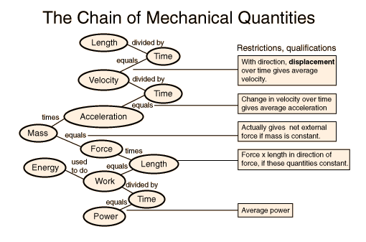
When measurement numbers with units are multiplied, you just multiple the units together according to the equation multiply/divide signs:
e.g., A (kg) * B (m) / C (s) + Z (kg-m/s) = D (kg-m/s)
This equation has units of momentum on BOTH sides of the equation and the terms on the left hand side have the same units.
Example: m*m = m² kg-s/m² * m-s² = kg-s³/m

Equivalence relations and unit conversion
The first thing to know to understand the math of unit conversion is that the mathematical equation: 12 inches = 1 foot is wrong! The equal sign is not like grenades or nuclear bombs where close counts, it means that the quantities on the two sides of the equation are exactly EQUAL! But, the expression
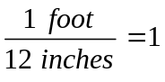 (unit-less) is a valid equivalence relation.
Let us derive the equivalence relation that involves, stating a unit relation as an equivalence and then dividing. Note that the units stay with their numbers and are algebraically manipulated the same as the numbers they are attached to.
1 inch = 2.5 cm >> divide both sides by 2.5 cm >> 1 inch / 2.5 cm = 2.5 cm/2.5 cm = 1 (unit-less)
2.5 cm = 1 inch >> divide both sides by 1 inch >> 2.5 cm/1 inch = 1 inch/ 1 inch = 1 (unit-less)
The important point here is that the equivalence relation is unit-less and equal to ONE and in math you can always multiple any term by a unit-less number equal to ONE without violating the sanctity of the EQUAL SIGN (this property is called the multiplicative identity and without it, math is kaputnik). Examples:

MKS Units
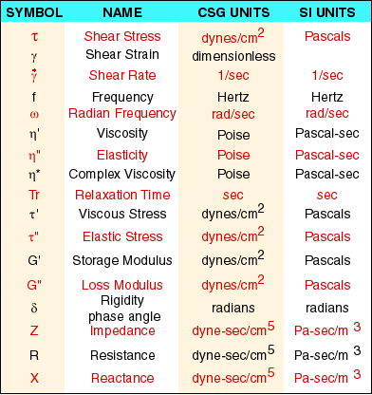
The obvious question to ask is how to decide what units to use for my measurement numbers? And the answer is: you can use any units you want so long as you are consistent! BUT, often it is convenient to use units which are naturally scaled to the problem at hand (e.g., km for big object and mm for small objects).
So how many kind of units are there? Actually, only three quantities are needed to derive all the units of physics! These three quantities are length, mass, and time.
Using the MKS unit system which is the ‘fundamental’ system, length is reckoned in meters (m), mass in kilograms (kg), and time in seconds (s). All other physics units are simply combinations of mass-kilograms-seconds (MKS)!
Velocity = m /s Acceleration = m / s² = m/s/s
Force in Newtons = kg m / s² Energy in Joules = N*m = kg*m²/s²
Power in Watts = J/s = kg*m²/s³ m/s/m/s = m²/s²

Significant figures used in calculations
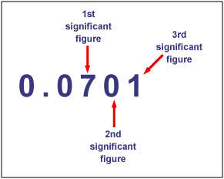
When one measures a number, the instrument measuring the physical value has a precision (e.g., gradations on the ruler) and the instrument also has accuracy (repeatability of the measurement). Thus, the physical value measured only has so many significant figures. And, after taking a measurement, if one writes down more significant figures, then dictated by the precision and accuracy of the measuring instrument, one is adding MORE precision/accuracy than is warranted! This could lead to an over-interpretation of the data measured. Of course, if you write-down LESS significant figures from your measurement, you are then LOSING valid information.
An important point to know is that when you calculate the value of an expression, your measured numbers are the numbers that determine the number of significant figures to carry in the calculation, not the pure-numbers in the expression.
e.g., C = 2*pi*R. Note that 2 and pi are pure numbers and have infinite precision (and no units!), but the measured value of radius (R in meters) will determine the significant figures for the circles circumference (C).
Note for multiplying/dividing, the term with the smallest number of significant figures determines the resultant number of significant figures. Whereas, for addition/subtraction, the minimum number of significant digits in the decimal part of the numbers determines the resultant number of decimals values (to the right of the floating point).
Scientific Notation
In geophysics, it is common to have to multiply 24,000,000,000,000,000,000,000 by .00000089973. If you don’t use scientific notion (mantissa and exponent), your potential for calculational error is enormous.
Use of scientific notation is powerful because the significant figures are all explicitly shown in the mantissa.
Note that there are two ways to represent the base of the exponent which are the same:
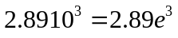 where e is the base value of the exponent (e.g., 10 in this case).
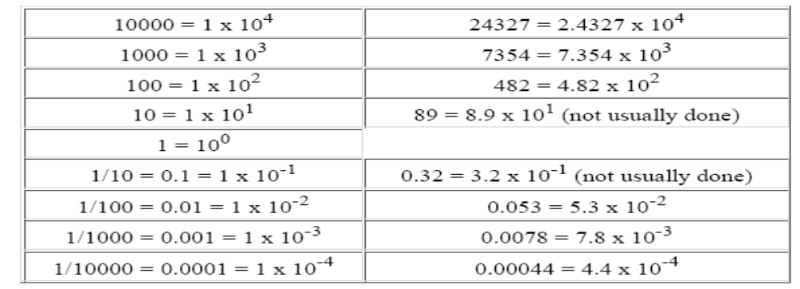
RULES:
- When you add/subtract terms, the exponents of the two terms MUST be the same!! That means you must adjust the decimal point in one of the mantissa values (and the exponent correspondingly!). Then, just add/subtract the mantissa values with the exponent remaining unchanged.
- When you multiple terms, you multiply the mantissa values together and ADD the exponents.
- When you divide terms, you divide the mantissa values together and SUBTRACT the exponents.

Functions and their inverse
A function is a foundational element of all mathematical equation solving. A function is simply defined as an equation that takes a number from the independent variable (domain) and gives back a number called the dependent variable (range).
All functions take a value from the argument (whatever you name it), and return the value of the function on the left hand side of the equations.
A graph is a plot of the function with the independent variable usually plotted along the ‘x-axis’ and the function values plotted along the ‘y-axis’. In general, one names the axis by the independent and dependent variables and place the units of these two numbers on the axes.
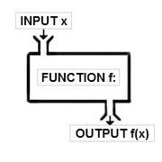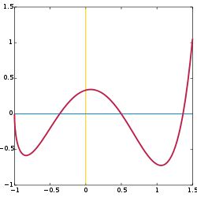
An inverse function is defined as:
Not all functions have inverses, at least over the functions full domain.
The horizontal line test tells you if a function has a full inverse.
Graphically, the inverse is the function graph reflected about the x=y line.
Solve for inverse in three algebraic manipulations
- replace f(x) with y
- swap x and y
- solve for y
*Note: f, x and y are just labels, you can call f, x and y whatever you desire.
Example:
- f(x) = 2x + 1 > y = 2x + 1 > x = 2y + 1 > y = (x – 1) / 2 > f⁻¹(x) = (x – 1) /2
Check: f⁻¹( f(x) ) = f⁻¹( 2x + 1) = ((2x + 1) – 1) / 2 = x ! f( f⁻¹(x) ) = f( (x – 1) / 2) = 2( (x-1)/2 ) + 1 = x !
- f(Ѳ) = 2*tan(Ѳ) > y = 2*tan(Ѳ) > Ѳ = 2*tan(y) > y = tan⁻¹(1/2* Ѳ)
check: : f⁻¹(f(Ѳ)) = f⁻¹( 2*tan(Ѳ) ) = tan⁻¹(1/2* 2*tan(Ѳ) ) = Ѳ !
The mother of all functions: sine and cosine
The sine and cosine function really are ultimate functions from which most other function can be made! But, for this class, let use note some properties of the sine and cosine functions. First, the functions ONLY oscillate between plus or minus one (the output range of the function or the independent variable) and their domain extends to plus or minus infinity. Second, sine and cosine are really the same function just shifted by pi/2 radians (equivalent to 90°). Third, the argument to the sine/cosine function must have no units! And, the function output has no units! A trigonometric equation only has units if you multiple by an amplitude term (which has units!).
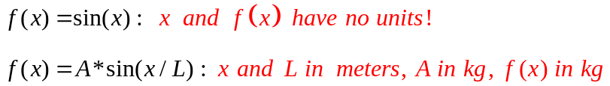
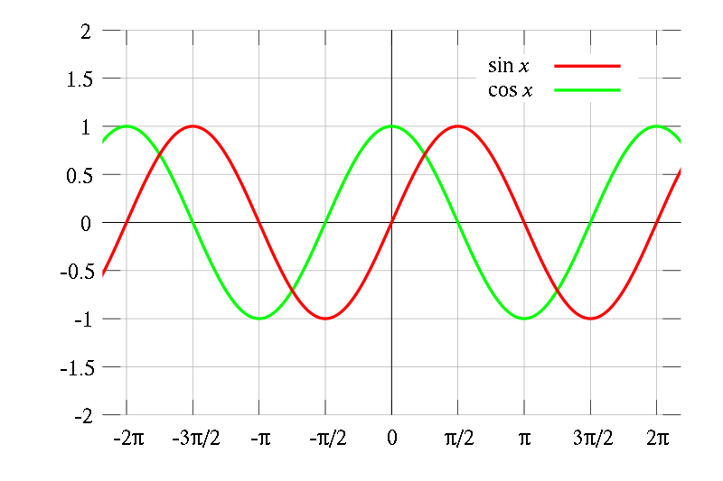
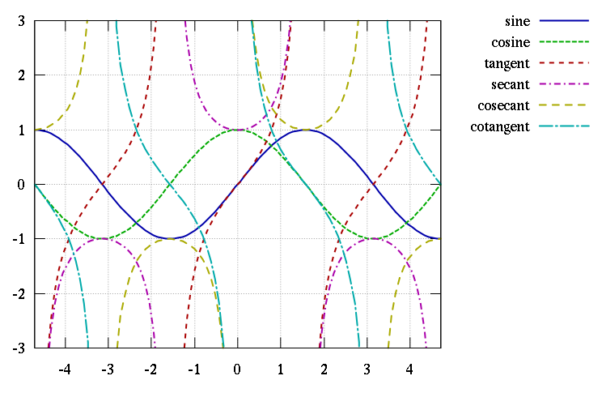

Basic math and trigonometric rules
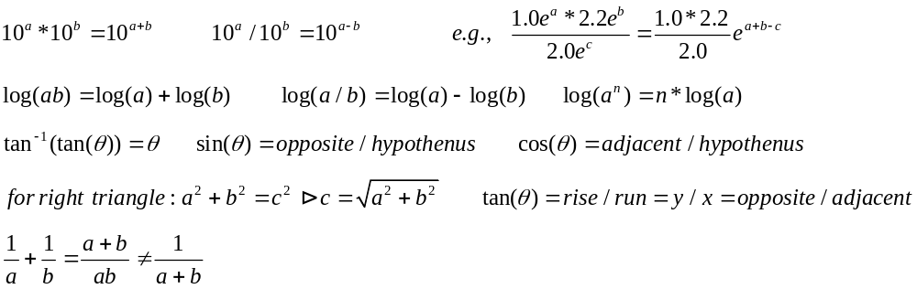
Coordinate systems
The simplest coordinate system is the Cartesian coordinate system with has three perpendicular axis typically called x,y,z axes (‘Cartesian’ is Latinized form of Rene Decartes name).
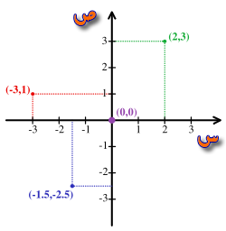
For spherical geometries (e.g., earth, sun, cows), a region of space is represented by the three spherical coordinates: r, Ѳ, φ.
For spherical symmetry situation, often a function of radius – F(r) - is all we need.
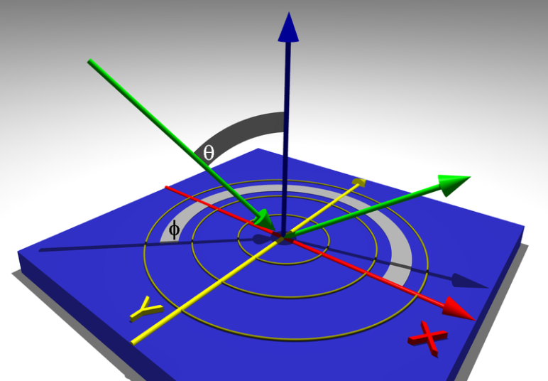

Force
An inertial force is a vector quantity that represents the change in momentum. A force always represents an interaction (e.g., collision between balls) between two objects where the force of object 1 on object 2 is opposite to the force of object 2 on object 1. It is wrong to say that one object applies a force to the other; they both apply equal and opposite forces on each other. Given that momentum is mass * velocity-vector, then by the definition of force is:
.
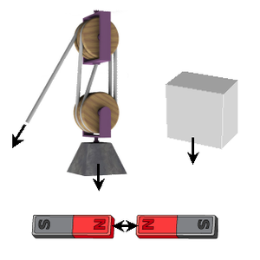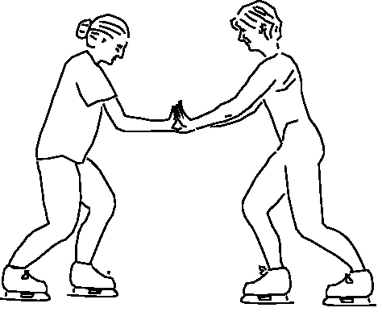

Gravity and Weight and Inertia
Using MKS units, Mass is measured in kilograms; Mass is the quantity that specifies the inertia of an object.
Mass is NOT the weight of an object; Mass is a measure of inertia.
Inertia is the resistance of an object to a change in its state of motion.
The state-of-motion is the velocity vector that describes the velocity of an object.
Velocity is a vector quantity. All vectors have a scalar magnitude which is the length of the vector: e.g., for velocity vector, the vector magnitude is the objects speed) All vectors have a direction either in two or three dimensional space.
Another way to view mass is the quantity of matter present in a volume: Mass = density * volume.
Thus, the mass in a volume is the number of molecules (atoms) * the molecular weight per atom.
There are two kinds of mass: inertial-mass and gravitational mass.
- Inertial mass is defined by F=ma or m = F/a
- Gravitation mass is define by g=G*m/r² .
Einstein proved inertial and gravitational mass are the same by viewing mass as a warping of the space and time around the mass. The mass tells the space-time how to warp and the warped space-time tells the masses how to move: planets around the sun!


